Pure Mysore Sandalwood Oil – India’s Liquid Gold for Global Wellness & Luxury | The Export Express

Introduction
For centuries, Indian Sandalwood (Santalum album) has been revered as one of the world’s most precious natural resources — a symbol of purity, spirituality, and luxury. The rich, woody aroma of Mysore Sandalwood Oil is unmatched, earning it the title “Liquid Gold of India.”
At The Export Express, we proudly export 100% pure, steam-distilled Mysore Sandalwood Oil, known for its therapeutic, cosmetic, and perfumery applications. Our oil is carefully sourced from sustainable plantations and distilled under expert supervision to maintain the essence of the world’s finest sandalwood.
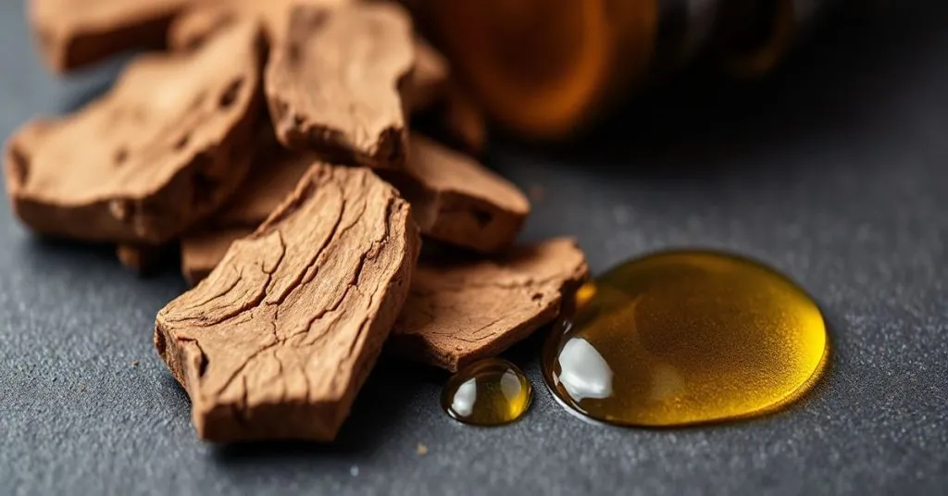
Caption: Steam-distilled Mysore Sandalwood Oil – 100% Pure & Natural, ready for export

The Legacy of Indian Sandalwood
Sandalwood, belonging to the genus Santalum, is a slow-growing aromatic tree native to southern India. Both the heartwood and the essential oil extracted from it have been treasured for thousands of years in Ayurveda, religious rituals, and perfumery.

Why Mysore Sandalwood Stands Apart
- Botanical Name: Santalum album
- Common Names: Indian Sandalwood, Chandan
- Origin: Mysore, Karnataka, India
- Wood Type: Heavy, yellow, and fine-grained
- Fragrance: Woody, warm, and sweet with lasting tenacity
Unlike synthetic substitutes, pure Mysore sandalwood retains its natural fragrance for decades, a testament to its purity and high oil concentration.
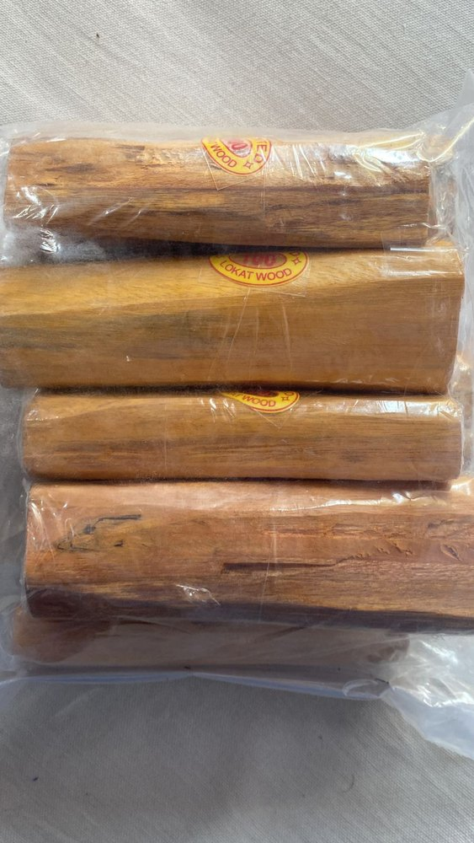
(Caption: Mature sandalwood heartwood ready for oil extraction)

India’s Exclusive Monopoly on Santalum Album Exports
India is the only country in the world authorized to produce and export genuine Santalum album (Mysore Sandalwood). Due to its rarity and conservation laws, export requires compliance with strict government regulations and certifications — ensuring authenticity and sustainability.
At The Export Express, we operate under full compliance with Indian forestry and export standards, offering international buyers guaranteed purity and traceability.
Our Certification Standards Include:
- FSSAI Certified
- ISO & GMP Certified
- Export Compliant with DGFT Regulations
- Lab-Tested for Quality & Purity

Technical Specifications
Property | Specification
Purity | 100% Pure, Natural, Undiluted
Botanical Name | Santalum album
Extraction Method | Steam Distillation
Color & Odor | Yellow with Musky, Woody Odor
Major Constituents | β-Santalol, Santyl Acetate, Santalenes
Specific Gravity (20°C) | 0.970 – 0.978
Refractive Index (30°C) | 0.962 – 0.976
Optical Rotation | (-15) – (-20)
Flash Point | 93.3°C
Solubility | Insoluble in Water; Soluble in Alcohol & Oils
Packaging Options | 1, 5, 10, 25, 50 & 180 kg HDPE Drums
Shelf Life | 24+ Months
Availability | In Stock

Extraction Process – Steam Distillation at Its Purest
Our Mysore Sandalwood Oil is extracted through steam distillation of the mature heartwood of Santalum album. This traditional yet precise process ensures that every drop of oil captures the natural santalol compounds responsible for its signature fragrance and therapeutic properties.
- Selection of Mature Trees: Only sandalwood aged 15–20 years is selected.
- Chipping & Powdering: Heartwood is ground to maximize surface area.
- Steam Distillation: Slow extraction under low pressure preserves aromatic integrity.
- Filtration & Testing: Each batch undergoes GC/MS analysis to confirm santalol concentration (>90%).
The result — a deeply aromatic, therapeutic-grade oil revered globally for perfumery, wellness, and spiritual use.

Therapeutic & Cosmetic Benefits

1. Skincare & Cosmetics
Sandalwood oil is a key ingredient in luxury skincare, thanks to its anti-inflammatory and antimicrobial properties. It soothes acne, enhances complexion, and provides deep hydration.
Used in: Serums, lotions, soaps, face oils, and perfumes.

2. Aromatherapy & Relaxation
In aromatherapy, sandalwood acts as a natural sedative and stress reliever, promoting relaxation and emotional balance. When diffused, it enhances concentration and uplifts mood.

3. Medicinal & Ayurvedic Applications
Ayurveda regards sandalwood as a “coolant” — balancing body heat, calming nerves, and aiding respiratory health. It is used in formulations for skin disorders, anxiety, and urinary infections.

4. Perfumery & Luxury Blends
With its long-lasting woody base note, Mysore sandalwood is an irreplaceable fixative in high-end perfumery. Leading fragrance houses around the world use it as the base for timeless scents.
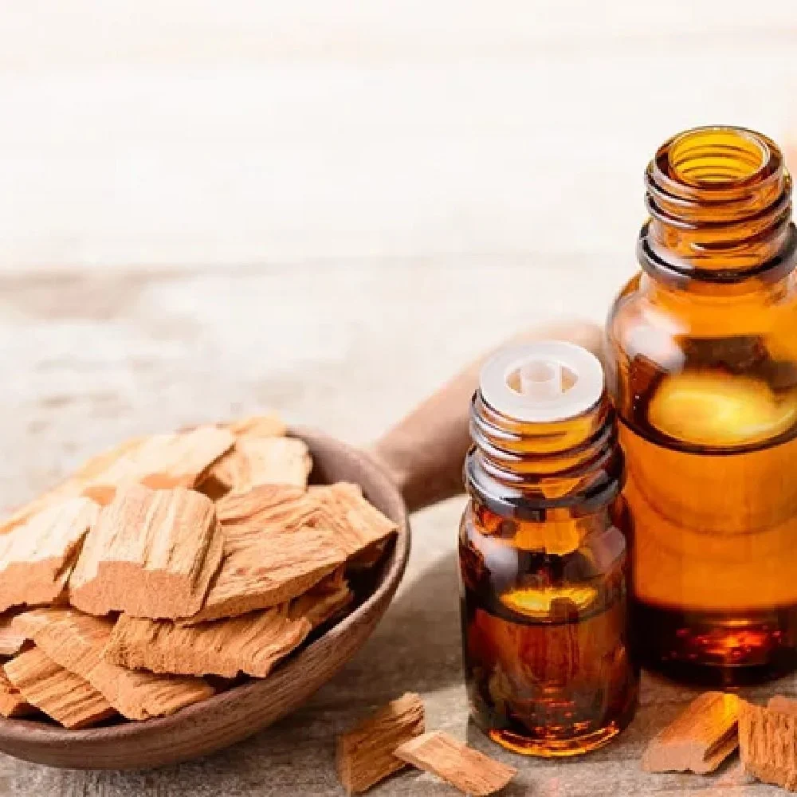
Caption: Sandalwood essential oil bottles in luxury perfumery setting

Why Sandalwood Oil is Called “Liquid Gold”
Mysore Sandalwood Oil is the second most expensive wood oil in the world, right after African Blackwood. Its global demand far exceeds supply due to slow tree growth and limited production zones in South India.
The oil’s value lies in:
- Its exquisite and long-lasting fragrance
- Versatility across skincare, perfumery, and wellness sectors
- Longevity: retains aroma for decades
- Cultural heritage: used in rituals, meditation, and holistic healing

Sandalwood Wood & Powder – Byproducts of Distillation
In addition to essential oil, The Export Express also offers sandalwood heartwood and powder for incense, cosmetics, and natural wellness formulations.
- Sandalwood Powder: Finely milled, aromatic, and ideal for face packs and traditional skincare.
- Sandalwood Wood Chips: Used in incense, meditation, and fragrance blends.
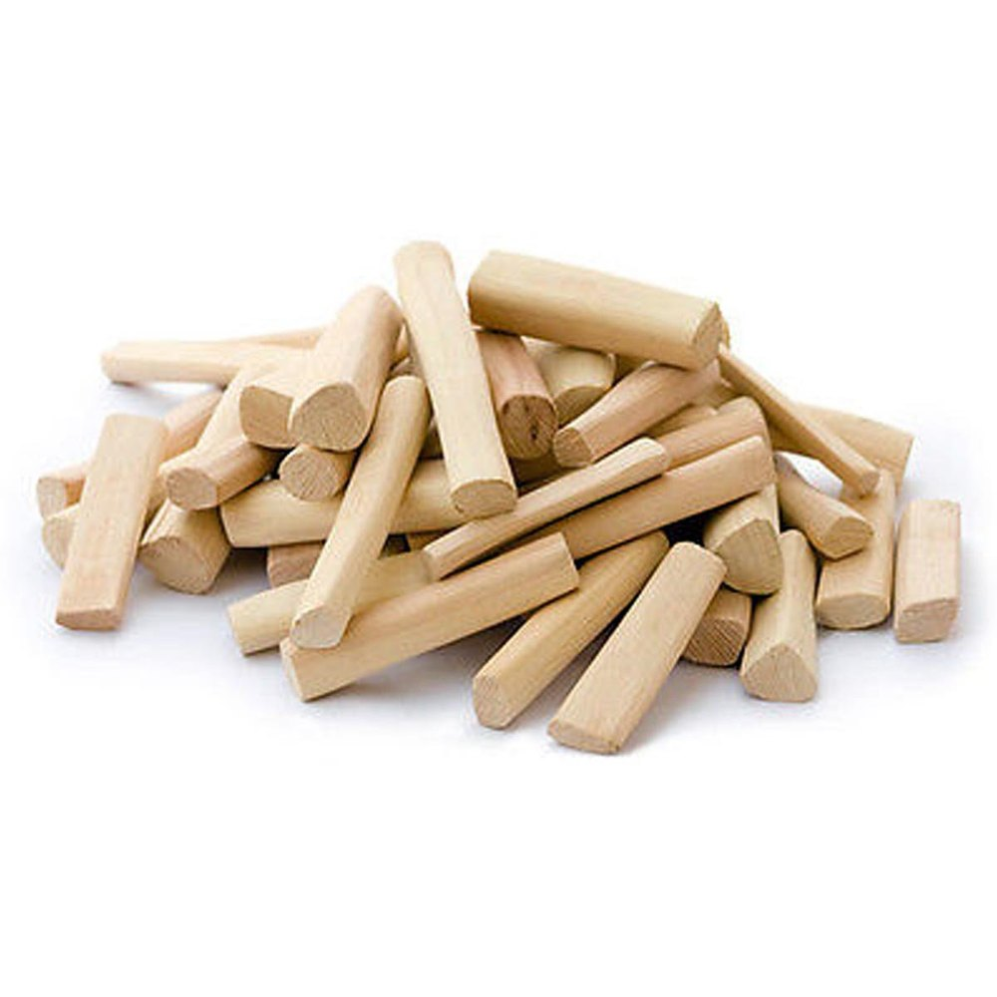
Caption: Sandalwood heartwood and powder ready for export

Global Export & Packaging
As a leading sandalwood oil exporter from India, The Export Express ensures secure packaging, global compliance, and timely shipment.

Packaging Options
- HDPE Drums: 1 kg to 180 kg
- Glass Bottles: For retail or sample exports
- Custom Private Labeling: Available on request
Export Markets: UAE, USA, Japan, France, Singapore, South Korea, and Australia
Every batch is shipped with Certificate of Analysis (COA), MSDS, and Phytosanitary Certification upon request.

Why Choose The Export Express?
- 100% Pure, Steam-Distilled Sandalwood Oil
- Direct Sourcing from Mysore, Karnataka
- FSSAI, ISO, and GMP Certified Manufacturing
- Custom Packaging for B2B, Private Label & Bulk Supply
- Competitive Pricing for Global Buyers
- Sustainable & Ethical Export Practices

Conclusion
Mysore Sandalwood Oil stands as a timeless symbol of India’s natural luxury — rare, aromatic, and profoundly therapeutic. At The Export Express, we combine heritage with precision, offering global buyers authentic, lab-tested sandalwood oil that embodies the soul of Indian craftsmanship.
From cosmetics and perfumery to wellness and spirituality, our sandalwood products promise purity, performance, and prestige — true to their legacy as India’s “Liquid Gold.”
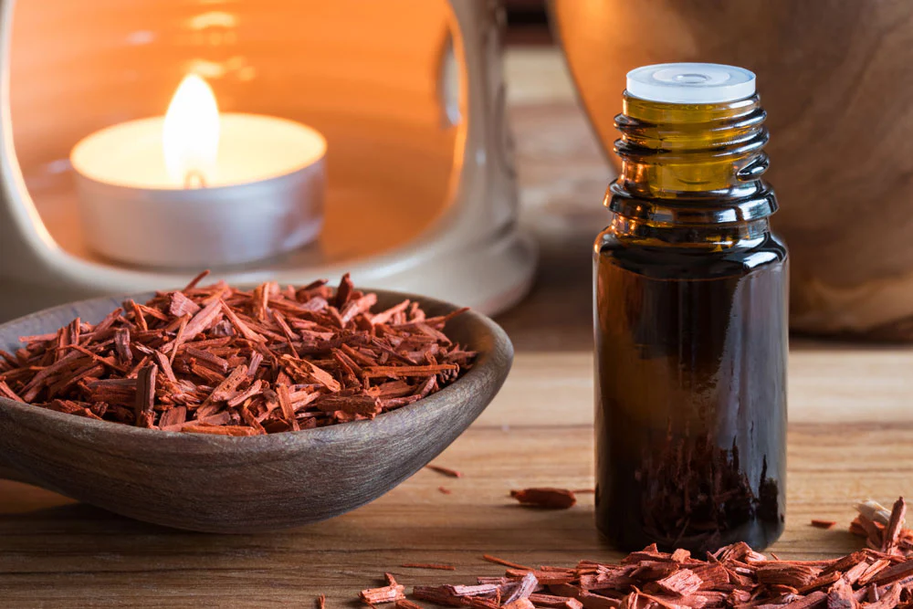
Caption: Premium export-grade sandalwood oil bottles by The Export Express

Meta Description
Pure Mysore Sandalwood Oil Exporter from India – The Export Express offers 100% natural, steam-distilled Santalum album oil with unmatched aroma, purity, and heritage.

